
PHILIPPINE GENERAL HOSPITAL
OUT PATIENT DEPARTMENT
SECTION OF ALLERGY AND IMMUNOLOGY
ALLERGY AND ADR
Follow up Form

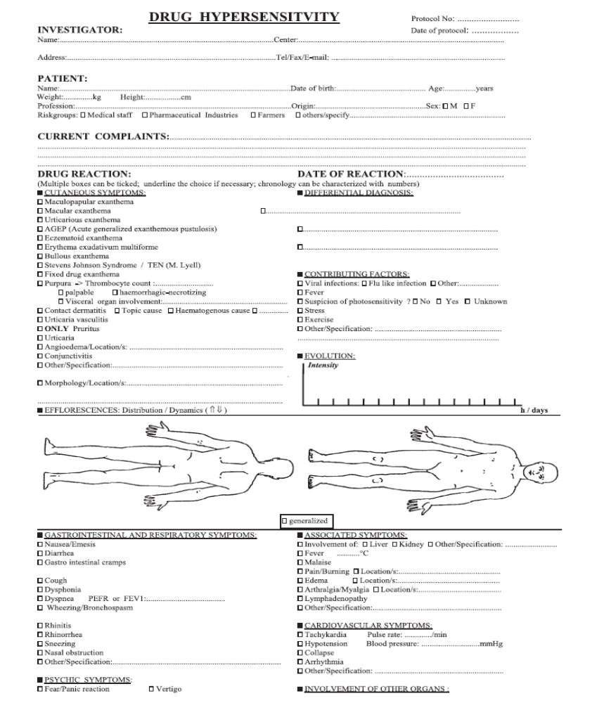

ENDA Questionnaire: European Network for Drug Allergy(Allergy 2009)

